35.24: a) 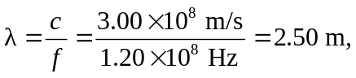and we have:
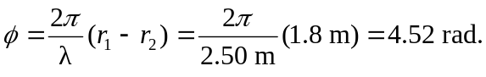
b) 